**56. Create and Use Custom Template**

--- **note** - you will learn how to define your own templates and use them.

--- tree

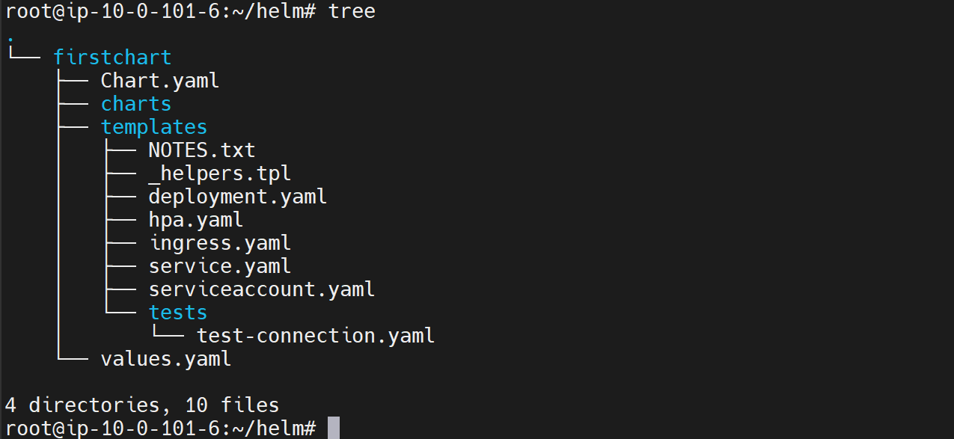

**Create your template in _helpers.tpl**

--- **note** – define a value in values.yml so I will use this value while define a function in _helpers.tpl

--- values.yml

nodeSelector: {}

tolerations: []

affinity: {}

myvalue: test

--- **note** – I defined my value at the end of the values.yml file.

--- vi _helpers.tpl

**{{/\***

**My custom template**

**\*/}}**

**{{- define "firstchart.mytemplate" -}}**

**{{- .Values.myvalue}}**

**{{- end }}**

{{/*

Expand the name of the chart.

*/}}

{{- define "firstchart.name" -}}

{{- default .Chart.Name .Values.nameOverride | trunc 63 | trimSuffix "-" }}

{{- end }}

--- **note** – defined a function in _helpers.tpl file. I can use above template in any deployment.yml…etc. files.

**Access the template in deployment.yml**

--- deployment.yml

apiVersion: apps/v1

kind: Deployment

  {{include "firstchart.mytemplate" . # we can pass any dictionary }}

spec:

  {{- if not .Values.autoscaling.enabled }}

  replicas: {{ .Values.replicaCount }}

  {{- end }}

  selector:

    matchLabels:

      {{- include "firstchart.selectorLabels" . | nindent 6 }}

  template:

    metadata:

      {{- with .Values.podAnnotations }}

      annotations:

        {{- toYaml . | nindent 8 }}

      {{- end }}

      labels:

        {{- include "firstchart.selectorLabels" . | nindent 8 }}

**Check the chart template**

--- **helm template firstchart**

# Source: firstchart/templates/deployment.yaml

apiVersion: apps/v1

kind: Deployment

**test**

spec:

  replicas: 1

  selector:

    matchLabels:

      app.kubernetes.io/name: firstchart

      app.kubernetes.io/instance: release-name

  template:

    metadata:

      labels:

        app.kubernetes.io/name: firstchart

        app.kubernetes.io/instance: release-name

--- **note** – we are successfully accessed the template form deployment.yml